## Feb 2, 2023 | [WGSAM skill assessment 2023](https://www.google.com/calendar/event?eid=M2hmZmgzZ3VibzVqbWxkZ2tuazNsc3Q3MHEgc2FyYWguZ2FpY2hhc0Bub2FhLmdvdg)

Attendees: [Grant Adams](mailto:adamsgd@uw.edu) [Alan Baudron](mailto:alan.baudron@gov.scot) [Floor Soudijn](mailto:floor.soudijn@wur.nl) [Francisco DeCastro](mailto:francisco.decastro@afbini.gov.uk) [Gustav Delius](mailto:gustav.delius@york.ac.uk) [Howard Townsend - NOAA Federal](mailto:howard.townsend@noaa.gov) [Isaac Kaplan - NOAA Federal](mailto:isaac.kaplan@noaa.gov) [Kiersten Curti](mailto:kiersten.curti@noaa.gov) [Marianne Robert](mailto:marianne.robert@ifremer.fr) [Carolyn McKeon](mailto:mckeonc2@tcd.ie) [Nis Sand Jacobsen](mailto:nsja@aqua.dtu.dk) [Pierre-Yves Hernvann - NOAA Affiliate](mailto:pierre-yves.hernvann@noaa.gov) [Robert Gamble](mailto:robert.gamble@noaa.gov) [Sarah Gaichas - NOAA Federal](mailto:sarah.gaichas@noaa.gov) [Sean Lucey - NOAA Federal](mailto:sean.lucey@noaa.gov) [Sigrid Lehuta](mailto:sigrid.lehuta@ifremer.fr) [valerio bartolino](mailto:valerio.bartolino@slu.se) [Vanessa Trijoulet](mailto:vtri@aqua.dtu.dk) Sigrid Lehuta

Notes

* Attendees: Sarah Gaichas, Kiersten Curti , Isaac Kaplan, Sean Lucey, Vanessa Trijoulet, Andy Beet,

**Overview of dataset**

<https://noaa-edab.github.io/ms-keyrun/reference/index.html>

<https://noaa-edab.github.io/ms-keyrun/index.html>

remotes::install_github("NOAA-EDAB/ms-keyrun")

**[Isaac trying to take notes, anyone else feel free to jump in !]**

**Datase**t is ready, as an R package, see above, including package and install info.

* **Mskeyrun is the R data packag**e. Output derive from NOBA Atlantis, with minimal bias.
* See detailed info on format, variable naming, etc.
* Exampl**e: catch index** : long data sets in tidyR.
* Example: **survey index**. One early season and one late season. Surveys are aggregated (non-spatial).
* Example: **Length comp data**: Includes length bin.
* Example: **age-length comp for surve**y . Note this includes Atlantis “age class”, which may be a single year or multi-year. Note that lengths are generated from Atlants by Sarah, since Atlantis is actually an age-based model.
* Example: **weight at age** : includes mean weight-at-age. This is mean weight at age per year and survey.
* **Diet comp**: this is by age class and prey. Values are diet comp. This is predator by age class, and prey (aggregated). **Valerio : how can we get prey size comp? Sarah: this is an issue to work out, driven by assumed predator preference**. Do we have prey weight? Sarah: no, we don’t know size of individual prey consumed by predators in Atlantis. Kierstin C: does Ataltnis output include predator-prey size comp or preferences and gape? Answer: hard to retrieve these from Atlantis. Valerio: can we think about predator selection of prey almost like a fishery selectivity– estimate these from output. Sarah: perhaps can come up with a way to capture predator-prey preference from the Atlantis output – so this can be passed to other models as a standard way. Example of realized diet (Atlantic Menhaden from atlantis, NEUS model)
* 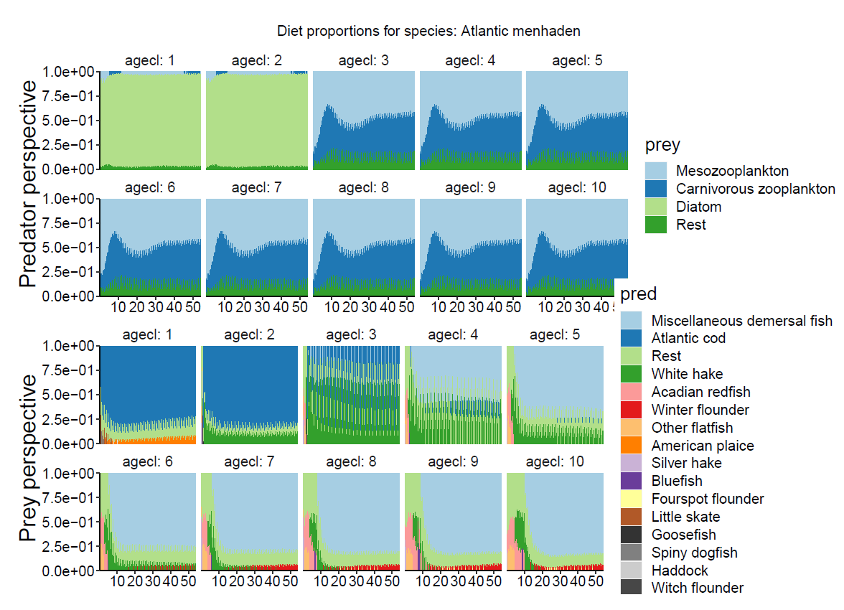
* More **discussion on diets and general discussion**:
  + Nis comment: fitting to ecosystem model as an OM can be challenging, and may tend to focus (necessarily) on details of the ecosystem model structure. But this limits the analysis. Sarah:M1 needs to calculated as well.
  + Kiersten: should each EM write out **how size preference is cal**culated and parameterized in each model? Sarah: could back out gape width from Atlantis. Grant: M1 is a bit easier I feel like, we can always estimate that from the data
  + Valerio: how to handle **“other food**”. ? This may vary across different EMs. Nis: “other food” dictates realized consumption by a predator on the detailed prey groups. Sarah: this could be pulled from Atlantis output, but is not an output currently.
  + Valerio: **what is timestep of output?** Sarah: Atlantis output is 5x per year. Fishery data is aggregated to annual. Surveys are specified as either spring or autumn currently. Valerio: wants detailed info **about seaso**n (timestep or month) of each survey. For catch as well, month or season would be useful. Sarah: currently, survey is just spring fall. Sarah could provide catch output at a monthly or 5x per year basis.
  + **Start year:** data start at year 55 [?]. Year 1-40 is a burn-in period for Atlantis.
  + **Extra species**: There are two unfished, age structured species in the Atlantis output.
  + **Species list: there are 10 fish species in the output**. Currently this does not include invertebrates. Sean: what about inverts? Sarah: could add dataset for invertebrate output and **full foodweb output**. .
  + **More output**: Sarah suggests we output Atlanti**s assumptions of gape (Atlantis params KLP and KUP are the lower and upper prey selection size limits. Gape limitation: useHardFeedingWindow = 0 or 1. Gape size by age is a function of body weight, from KLP*SN to KUP*SN, where SN= structural nitrogen for useHardFeedingWindow = 1) ,** and assumptions of **maturity ogive per age class (called FSPB in Biol.prm)** (as well as years per age class)
  + Diet comp: currently aggregated per simulation year, for each age class of predators. Valerio asks for seasonal diet info with timestamp.
  + Terminology: Atlantis “age classes”. Example from Isaac: sardine may have 10 age classes of 1 year each, because their lifespan is 10 years. Long-lived fish such as redfish may have 10 age classes but each age class is 4 years long (because the lifespan is 40 years). See AgeLenComp which lists age class and length bins.
  + **Consumptio**n: Outputs include per capita consumption per predator age class, annual output. Grams per individual per day.
* More datasets: **example: Bottom temperature**
* More datasets: **weight at age**, changes over time. In fishery or in spring vs fall survey. Changes in weight at age. Valerio– what drives this– fishing, consumption , or? Sarah – weight at age varies due to fishing, consumption (and temperature). **Sarah – consumption output is realized consumption and how it varies over time, per predator**.

**Timeline**

* Valerio asks for goal and timeline for next WGSAM in October. Need input from EM folks.
* **Valerio wants to** get commitment form EM folks . Leverage work already by Hydra and ? other model.
* Aim? Look at EM output in October , with preliminary EM parameterizations. Even if the multispecies models are only run in single-species mode.
* Aim for 2-3 check-in meetings.
* See old notes on **subset of key species to focus** on (not all 10). .

**Hydra EM model: example output from Sarah**

* Fits of Hydra to Atlantis output. Demo from 11 species.
* This is somewhat of a work in progress (more work by Gavin Fay too, recently).
* No time-varying parameters. Estimating fishing mortality and recruitment annually.
* Skill summary statistics: AE, AAE, ME, and RMSE
* Comments: Gustav – how to avoid overfitting? Use training vs test data to quantify overfitting? Sarah: initial thought was skill assessment vs observed data from the OM.
  + Valerio idea: consider asking EM folks to omit last 10 years of Atlantis output, then later we can use those last 10 years as out-of-sample test.
  + Sarah – could look at things like 3 year forecasts of catch. (see old notes).

**[Isaac trying to take notes, anyone else feel free to jump in !]**

Action items

* Sarah to generate datasets with subannual timesteps
* Sarah to add true parameters to datasets (gape width, maturity)
* Individual modeling groups to plan for using datasets
  + Gadget, digest data and think about subset of predators to model
  + Others?
  + Add issues to github <https://github.com/NOAA-EDAB/ms-keyrun/issues>
* Resurrect [notes previously](https://docs.google.com/document/d/17jB5Q5aXL7976P9945G75rLKHf6Ka3vT4FgCsY3Bar0/edit#heading=h.5xhv60yaxqg7) on directions to take
  + Did we discuss using a subset of species and which ones?
* Schedule next meeting–at least two prior to WGSAM 2023, every 3 months
  + Late April after ICES assessment season winds down
  + Again before everyone leaves for summer, early June?
  + Early September checkin?
* Aim for preliminary parameterizations to show using common dataset for WGSAM 2023